Question 1: Kleene’s Theorem(Closure and Union Of DFA) 10 Points

Find the Union and Concatenation of FA1 and FA2 given in figure 1 and figure 2 and
closure of FA2 given in figure 2 .

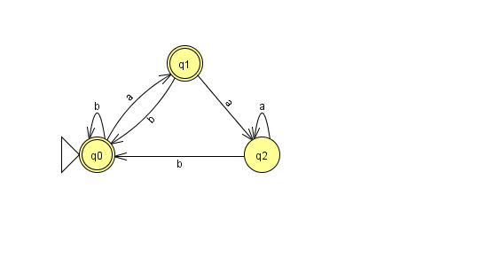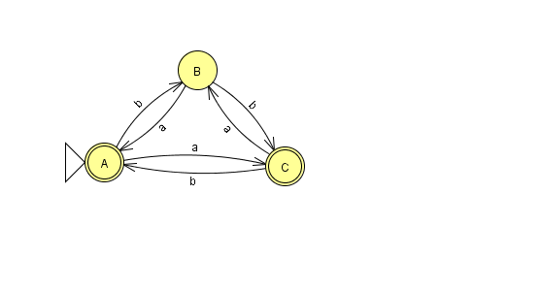

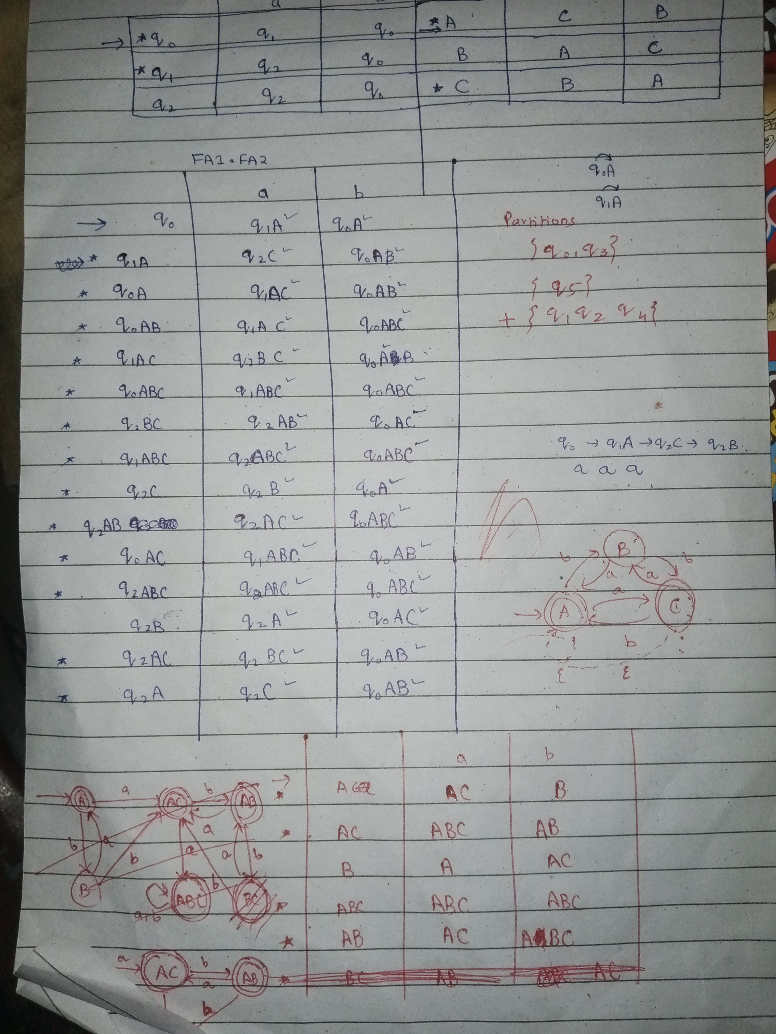
Closure
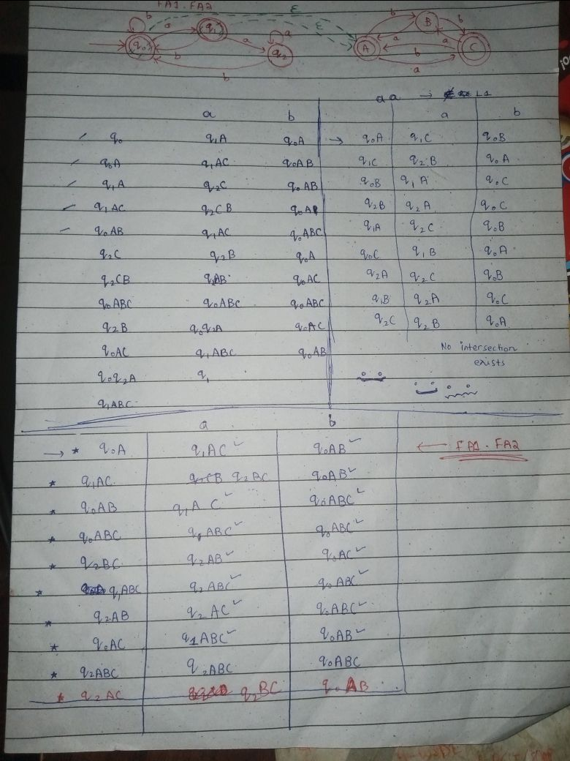
Ignore these

P.S. You’ll see two FA1.FA2 transition tables. Both are correct. The one on this page is more efficient because both initial states were also final states, so it’s okay to merge both of them.

Question 2:DFA Minimization

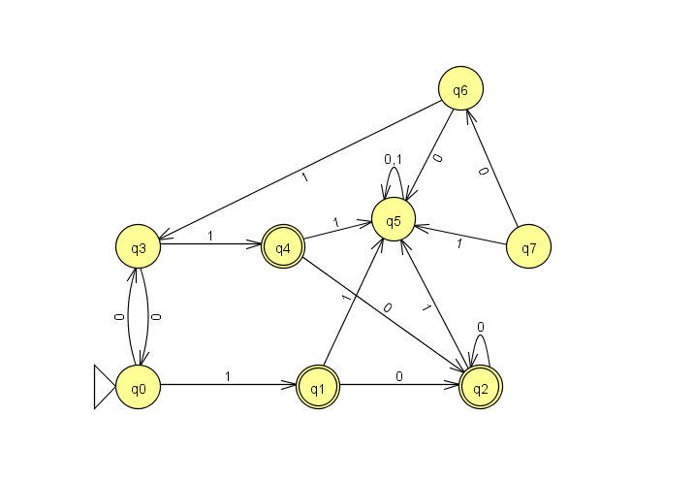

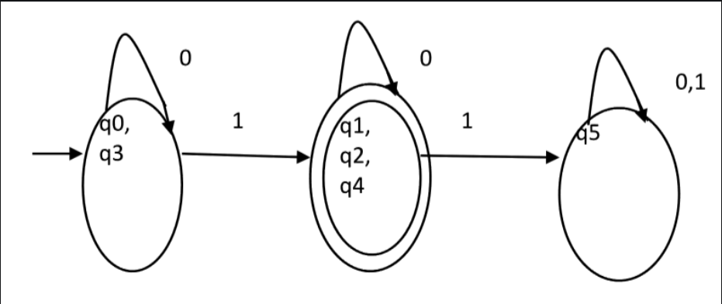

Question 3: Grammar
Convert the following CFL to CFG, then convert the grammar to equivalent RE:
- (x^n)(b^n+2) ; n > 0
- (u^2n+3)( v^n) ; n > 0—----> Answer: S—>uuSv|uuu
- (x^m) (y^n) ; m > n ; n > 0\

Left Linear Grammar

1.L = { w ∈ {a,b} | w ends with “ab” }*
S → Tb
T → Ua
U → Ua | Ub | ε
2. L={w ∈ {a,b}*∣w starts and ends with the same symbol}
S → Aa | Bb | a | b
A → Aa | Ab | a
B → Ba | Bb | b
Right Linear Grammar

1.All strings with exactly two a’s and more than two b’s.
S0 → b S1 | a A0
S1 → b S2 | a A1
S2 → b S3 | a A2
S3 → b S3 | a A3
A0 → b A1 | a B0
A1 → b A2 | a B1
A2 → b A3 | a B2
A3 → b A3 | a B3
B0 → b B1
B1 → b B2
B2 → b B3
B3 → b B3 | ε
2.All strings with no more than 3 a’s.
S → aA | bS | a | ε
A → aB | ba | A | a | ε
B → bB | aC | ε
C → bC | b | ε

CFG
1.L = { aⁿbᵐ | n ≠ m }
S → AS1 | S1B
S1 → aS1b | ε
A → aA | a
B → bB | b

2.L = { aⁿbᵐcᵏ | n = m or m ≤ k }
S → S₁C | AS₂
S₁ → aS₁b | ε
S₂ → bS₂c | C
C → cC | ε
A → aA | ε

3. L={a^n b^m | n = m-1 }
S → aSb | b

Question 4: Simplification

Q. Consider the following grammar:
S → ASA | AB | BCD | DFG | EFG | AFG
A → Abc | BCa | aAc |ε
B → BD | AD | bAD
C → cCb | bCD | bAC
D → dD | ε
F → EF | CD | bCF | ef
Simplify the grammar and show all the steps.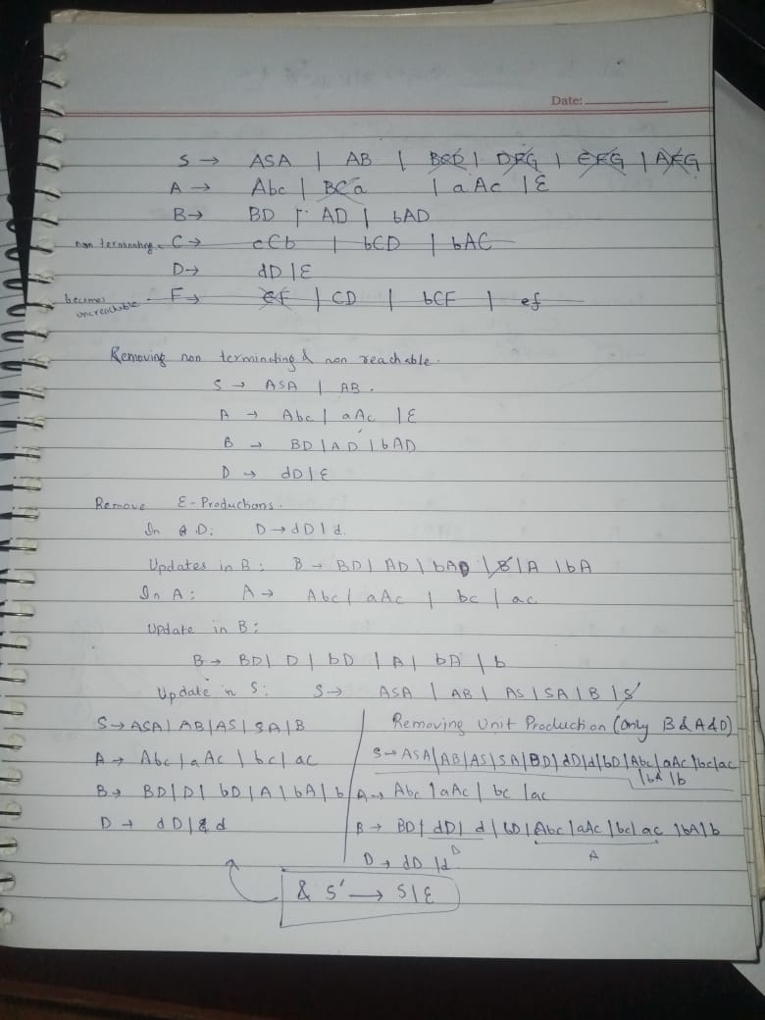
| bAD
| bAD
| bAD

